Section 9 – Session Storage and Persistence

142. Local Storage and Persistence – use of library redux-persist

a. window.localStorage.getItem and setItem

b. can only store string

c. JSON.stringify = converts object to string

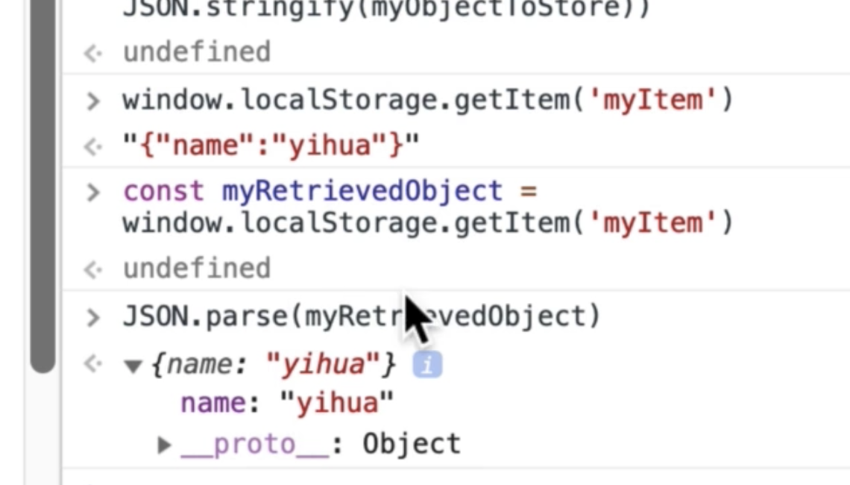

d. localStorage = stores data even if the browser is closed

e. sessionStorage stores only the data up to refresh. Lost data when browser is closed.

143. Redux Persist

a. npm I redux-persist

b. configure it in store.js

1. import { persistStore } from ‘redux-persist’

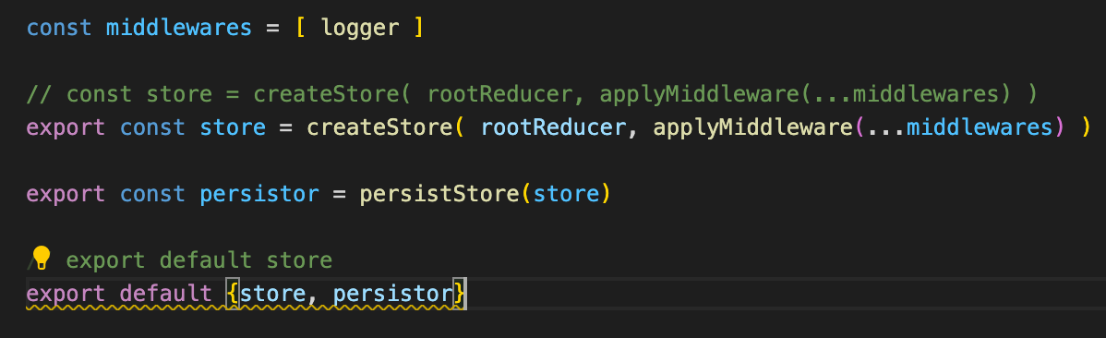

c. in root-reducer.js

1. import { persistReducer } from ‘redux-persist’

2. import storage from ‘redux-persist/lib/storage’

3. define a persist object

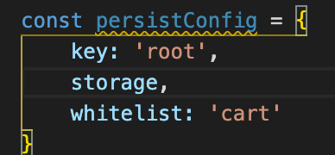

4. redefine the combineReducer and make it as the rootReducer

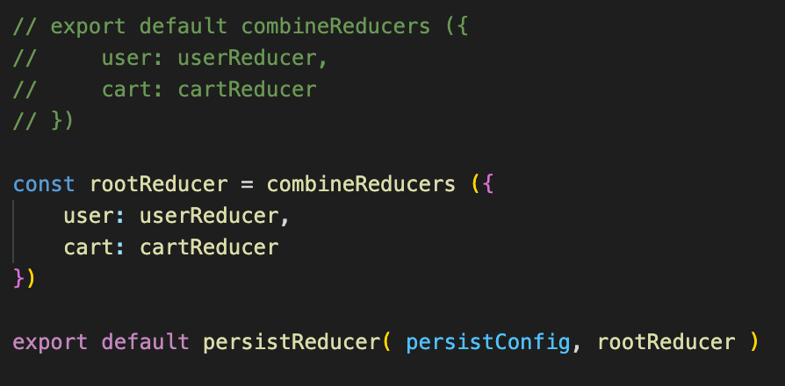

5. Bring in the actual persistor in the index.js

1. import { PersistGate } from ‘redux-persist/integration/react’

2. import persistor

3. Wrap the <App /> with the <PersistGate persistor={persistor}>

4. The app now be able to persist the data / cart.